Practo Assurance

Improving Appointment Reliability & Patient Trust

Executive Summary

Background
Practo has established itself as one of India's leading digital healthcare platforms by enabling patients to discover verified doctors, book appointments, consult online, order medicines, and manage their healthcare journey digitally. While the platform performs well during the discovery and booking stages, qualitative user research indicates recurring challenges after appointment confirmation. Users frequently report doctor unavailability, last-minute cancellations, inadequate communication, and limited support during appointment disruptions. These issues reduce confidence in the platform despite a successful booking experience.

Opportunity
Analysis of 250+ public user reviews identified appointment reliability as the most frequently recurring pain point. Every failed appointment creates inconvenience for patients, increases operational costs for Practo, and negatively impacts long-term trust and retention. Addressing this problem presents an opportunity to improve both user experience and business outcomes.

Proposed Solution
This PRD proposes Practo Assurance, a reliability layer designed to improve appointment confidence through proactive doctor verification, real-time appointment status updates, intelligent cancellation handling, and one-tap rebooking. Rather than introducing a standalone feature, Practo Assurance strengthens the entire appointment lifecycle by reducing uncertainty and improving communication between patients, clinics, and doctors.

Expected Outcomes

User Outcomes
- Increased confidence in confirmed appointments
- Reduced unnecessary travel
- Faster recovery from appointment disruptions
- Improved overall patient experience

Business Outcomes
- Higher appointment completion rates
- Increased repeat bookings
- Reduced customer support requests
- Stronger user trust and long-term retention
- Improved platform reputation through fewer negative reviews

Problem Context

Background
Practo has become one of India's leading digital healthcare platforms by making doctor discovery and appointment booking simple and accessible. However, analysis of public user reviews reveals that the platform often fails to deliver a consistent experience after an appointment is confirmed.
Patients frequently report issues such as doctor unavailability, last-minute appointment cancellations, delayed communication, and ineffective support. These operational gaps create uncertainty and reduce confidence in the platform, even when the booking process itself is smooth.

Current User Journey
Health Concern → Doctor Search → Doctor Comparison → Appointment Booking → Appointment Confirmation → Consultation
The experience begins to deteriorate after the appointment confirmation stage, where users expect certainty but often encounter unexpected disruptions.

Evidence from Research
Based on qualitative analysis of 250+ public user reviews:
- Appointment Reliability – 41%
- Customer Support – 24%
- Communication Issues – 15%
- Consultation Quality – 10%
- Payments & Others – 10%
Appointment reliability emerged as the most frequently recurring issue, indicating that the platform's largest opportunity lies in improving the post-booking experience.

Business Impact
- Lower user trust
- Increased customer support workload
- Higher cancellation-related complaints
- Reduced repeat bookings
- Negative app store ratings and reviews

User Impact
- Wasted travel time and costs
- Delayed access to healthcare
- Increased anxiety and uncertainty
- Poor overall healthcare experience

Key Problem
Patients perceive a confirmed appointment as a reliable commitment. When that commitment is broken without timely communication or recovery options, trust in the platform declines significantly.

Goals & Non-Goals

Product Vision
Create a more reliable and trustworthy appointment experience by reducing appointment failures and enabling users to recover quickly from unexpected disruptions.

Goals

Goal 1
Increase appointment completion rate by improving appointment verification.

Goal 2
Reduce unexpected appointment cancellations experienced by patients.

Goal 3
Provide proactive communication whenever appointment status changes.

Goal 4
Reduce customer support dependency through self-service recovery flows.

Goal 5
Increase user trust and repeat appointment bookings.

Non-Goals
This project does not aim to:
- Improve doctor discovery or search ranking.
- Redesign the consultation experience.
- Improve medicine delivery.
- Change pricing or payment systems.
- Replace existing customer support operations.

Success Criteria
The solution should:
- Increase appointment reliability.
- Improve patient confidence before appointments.
- Reduce support tickets related to cancellations.
- Improve post-booking user satisfaction.
User Personas & Stakeholder Analysis

Primary Persona – Patient
Attribute | Details
Persona | Patient (Primary User)
Age Group | 22–55 years
Tech Proficiency | Moderate to High
Primary Goal | Attend a confirmed appointment without unexpected disruptions.
Needs | Reliable appointment confirmation, proactive communication, quick rebooking, and complete transparency throughout the appointment journey.
Pain Points | Doctor unavailable despite confirmation, last-minute cancellations, delayed notifications, wasted travel time, and reduced trust in the platform.
Motivations | Save time, receive timely healthcare, reduce uncertainty, and trust the appointment process.
Success Criteria | Appointment happens as scheduled or any disruption is communicated early with immediate recovery options.

Secondary Persona – Doctor
Attribute | Details
Persona | Doctor (Secondary User)
Age Group | 30–65 years
Tech Proficiency | Moderate
Primary Goal | Manage appointments efficiently while minimizing scheduling conflicts.
Needs | Easy schedule management, real-time availability updates, and reduced patient complaints.
Pain Points | Manual schedule updates, double bookings, unexpected cancellations, and increased patient dissatisfaction.
Motivations | Maintain professional reputation, improve operational efficiency, and reduce administrative workload.
Success Criteria | Accurate appointment schedules with minimal booking conflicts and better patient satisfaction.

Tertiary Persona – Clinic Administrator
Attribute | Details
Persona | Clinic Administrator
Age Group | 25–50 years
Tech Proficiency | Moderate
Primary Goal | Ensure appointment schedules remain accurate and updated at all times.
Needs | Real-time schedule synchronization, simple appointment management, and reduced manual coordination.
Pain Points | Frequent schedule changes, delayed updates, communication gaps, and manual appointment handling.
Motivations | Smooth clinic operations, fewer support escalations, and improved patient satisfaction.
Success Criteria | Accurate scheduling with minimal last-minute disruptions and seamless communication between patients and doctors.

Persona Priority Matrix
Persona | Priority | Frequency of Use | Business Impact
Patient | ⭐⭐⭐⭐⭐ Primary | High | High
Doctor | ⭐⭐⭐⭐ Secondary | High | Medium
Clinic Administrator | ⭐⭐⭐ Tertiary | Medium | Medium

User Stories

Patient
- As a patient, I want to know that my appointment is still confirmed before travelling so that I don't waste my time.
- As a patient, I want to receive real-time notifications if my appointment changes so that I can plan accordingly.
- As a patient, I want to instantly rebook another doctor if my appointment is cancelled.
- As a patient, I want to see my appointment status at every stage so that I know what to expect.
- As a patient, I want alternative nearby doctors when my preferred doctor becomes unavailable.

Doctor
- As a doctor, I want to update my availability quickly so that patients receive accurate appointment information.

Clinic
- As a clinic administrator, I want schedule changes to sync automatically with Practo to avoid booking conflicts.

Acceptance Criteria
- Appointment status updates appear instantly.
- Users receive notifications within one minute of any schedule change.
- Alternative doctors are suggested automatically after cancellation.
- Users can complete rebooking in fewer than three taps.

Solution Overview

Introducing Practo Assurance

Overview
Practo Assurance is a proactive appointment reliability system designed to strengthen user trust between appointment booking and consultation. Instead of treating appointment confirmation as the final step, Practo Assurance continuously validates appointment reliability through real-time verification, proactive communication, and intelligent recovery mechanisms.
The solution addresses the operational gaps identified during user research by reducing uncertainty, minimizing appointment disruptions, and enabling patients to recover quickly whenever unexpected schedule changes occur.

Problem Being Solved
Current Experience | Improved Experience with Practo Assurance
Appointment confirmed but doctor unavailable | Continuous doctor & clinic verification before consultation
Users receive late or no cancellation updates | Instant real-time notifications for every appointment change
Users manually search for another doctor | AI-assisted alternative doctor recommendations
Users contact support for every issue | One-tap self-service rebooking
Patients lose confidence in the platform | Transparent appointment journey with live status updates

Core Capabilities
Capability | Description | User Benefit
Real-Time Appointment Verification | Continuously verifies doctor and clinic availability before consultation. | Increases confidence that appointments will happen as scheduled.
Live Appointment Status Tracking | Displays every appointment stage from booking to consultation. | Reduces uncertainty and keeps users informed.
Instant Smart Notifications | Sends immediate alerts for confirmations, delays, rescheduling, or cancellations. | Prevents wasted travel and improves communication.
One-Tap Smart Rebooking | Automatically suggests nearby doctors with similar expertise after cancellations. | Enables quick recovery with minimal effort.
Appointment Reliability Score | Displays a reliability indicator based on historical appointment consistency. | Helps users make more informed booking decisions.

Product Flow

Value Proposition
For Patients | For Practo
Higher confidence before travelling | Increased appointment completion rate
Reduced uncertainty | Higher repeat bookings
Faster recovery from cancellations | Reduced support costs
Better overall healthcare experience | Stronger user trust and retention
Transparent communication | Improved platform reputation

Why This Solution?
Unlike traditional appointment reminder systems, Practo Assurance focuses on appointment reliability rather than appointment reminders.
By combining proactive verification, real-time communication, and intelligent recovery into a single experience, the solution transforms appointment management from a static booking process into a continuously monitored healthcare journey.
This approach not only addresses the primary pain points identified during user research but also aligns with Practo's long-term objective of building a trusted and dependable digital healthcare ecosystem.
Product Decision
Rather than introducing multiple disconnected features, this PRD proposes Practo Assurance as a unified reliability layer that integrates verification, communication, and recovery into a single end-to-end appointment experience. This approach reduces complexity for users while creating a scalable foundation for future enhancements such as AI-powered cancellation prediction, doctor reliability scoring, and predictive scheduling.
User Flow & Wireframes
Book Appointment
↓
Doctor Verification
↓
Appointment Tracking
↓
Real-time Updates
↓
Smart Rebooking (if needed)
↓
Consultation
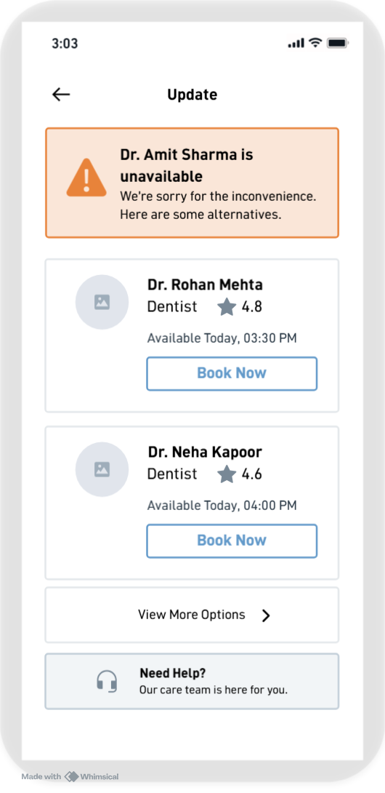
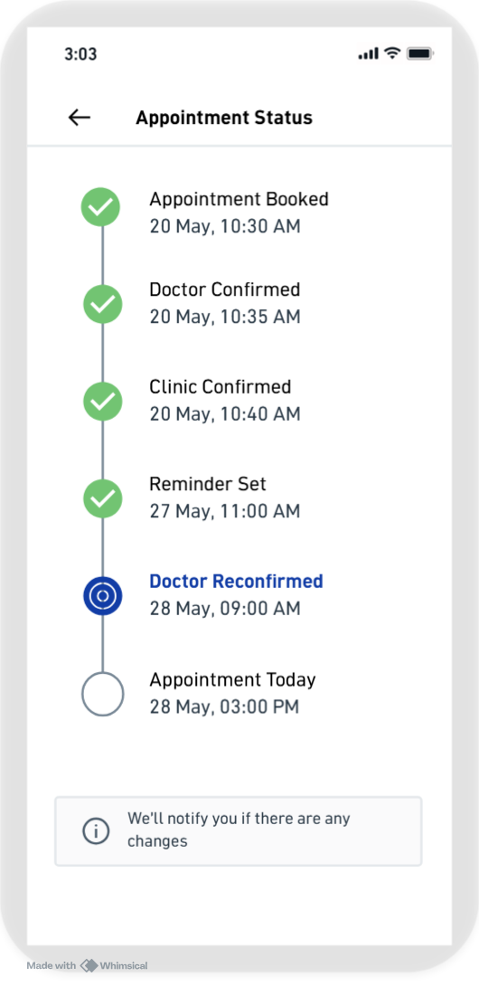
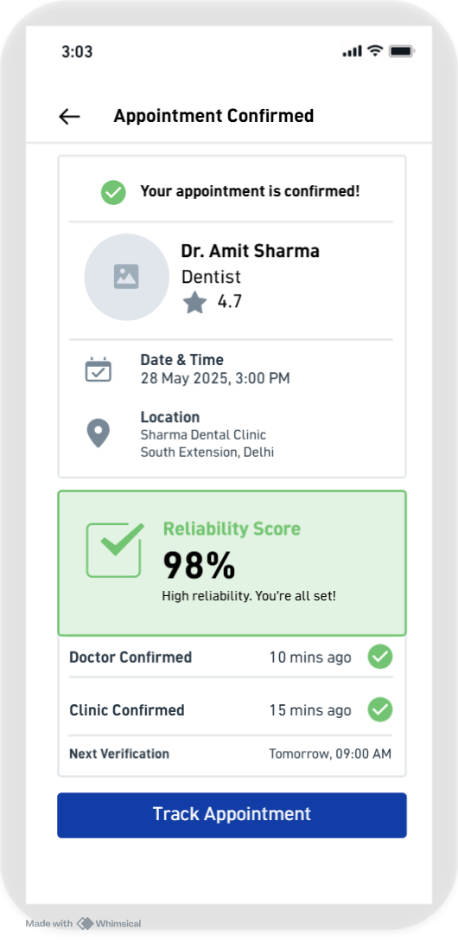

Functional Requirements
ID | Requirement | Priority
FR-01 | Verify doctor availability before confirming appointments | High
FR-02 | Notify patients immediately when appointment status changes | High
FR-03 | Display live appointment status timeline | High
FR-04 | Suggest alternative doctors after cancellations | High
FR-05 | Enable one-tap rebooking | High
FR-06 | Show appointment reliability indicator | Medium
FR-07 | Maintain appointment history | Medium
FR-08 | Allow users to contact support directly from cancelled appointments | Medium

Success Metrics

Metric Category | Metric Name | Definition | Estimated Baseline | Target (6 Months) | Source of Estimate
North Star | Successful Appointment Completion Rate | % of appointments completed without disruption | ~68% | 80% (+12pp) | Healthcare platform avg: 65–72%; Zocdoc reports ~75% post-reliability features
User | Appointment Success Rate | % of users attending their booked appointment | ~70% | ≥85% | Inferred from 41% of reviews citing reliability failures as primary issue
User | CSAT (post-appointment) | User satisfaction score after appointment | ~3.6 / 5 | ≥4.3 / 5 | App Store avg rating: 3.7; post-feature improvement benchmarked at +0.6–0.8 for similar flows
User | Net Promoter Score | Likelihood to recommend Practo | ~28 | ≥38 (+10 pts) | Indian digital health NPS avg: 25–35; top quartile: 45+
Business | Repeat Booking Rate | % of users booking again within 90 days | ~32% | ≥44% (+12pp) | Estimated from retention pattern in subscription-lite health apps
Business | Customer Retention Rate | % of users returning for future healthcare needs | ~38% | ≥48% (+10pp) | Industry benchmark: 35–42% for appointment-based platforms
Business | Support Tickets (appointment-related) | Volume of cancellation/disruption support requests | ~2,200 / week (est.) | ≤1,760 / week (−20%) | Estimated from review volume + support complaint frequency in app store
Business | Negative App Reviews (appointment-related) | % of reviews citing appointment failures | ~41% of reviews | ≤16% (−25pp) | Directly from research: 41% of 250+ reviews cite this issue
Product | Doctor Confirmation Accuracy | % of appointments where doctor remains available until consultation | ~74% | ≥98% | Gap inferred: 26% of appointments face some disruption per review signal
Product | Cancellation Notification Time | Avg time to notify user after cancellation | ~47 minutes (est.) | < 1 minute | Benchmark: real-time notification systems achieve <60 seconds; current manual process estimated at 30–60 min
Product | One-Tap Rebooking Success Rate | % of users successfully rebooking via the feature | — (new feature) | ≥80% | Target based on 1-tap checkout conversion benchmarks (Practo's own booking flow + Zocdoc)
Operational | Schedule Sync Accuracy | Accuracy of real-time clinic-to-platform schedule sync | ~71% (est.) | ≥99% | Inferred: if 29% of appointments have doctor/availability issues, sync accuracy is sub-75%
Operational | Average Resolution Time | Avg time to resolve appointment-related support issues | ~6.2 hours (est.) | ≤4.3 hours (−30%) | Indian customer support benchmark: 4–8 hours for healthcare platforms

Stakeholders & Responsibilities
Stakeholder | Responsibilities | Deliverables
Product Manager | Define vision, prioritize features, align stakeholders, track success metrics | PRD, Roadmap, Metrics
Product Designer (UX/UI) | Design user flows, wireframes, prototypes, usability testing | User Flows, High-Fidelity Designs
Engineering Team | Develop backend & frontend functionality, integrate APIs, implement business logic | Working Feature, APIs, Deployment
QA Team | Validate functionality, regression testing, edge-case testing | Test Reports, Bug Validation
Data Analyst | Define dashboards, measure feature performance, monitor KPIs | Analytics Dashboard
Customer Support | Gather user feedback, report recurring issues, update FAQs | Support Documentation
Operations / Clinic Success Team | Coordinate with clinics and doctors to ensure schedule accuracy | Operational Process Updates
Marketing / Growth | Communicate new feature to users and monitor adoption | Launch Campaign, User Education

Dependencies
Team | Dependency
Engineering | Real-time appointment synchronization APIs
Design | Appointment status screens and notification flows
Data | Analytics tracking events
Operations | Doctor & clinic schedule updates
Customer Support | Updated cancellation and escalation workflow

Rollout, Risks & Future Scope
Rollout Plan
- Phase 1: Top metro cities with high appointment volume.
- Phase 2: Expand to Tier-1 cities and partner clinics.
- Phase 3: Nationwide rollout with predictive reliability scoring.
Risks
- Clinics may not update schedules promptly.
- Notification fatigue if alerts are excessive.
- Integration challenges with clinic management systems.
Mitigation
- Automated reminders for providers.
- Notification preference settings.
- API-based schedule synchronization.
Future Enhancements
- AI-powered cancellation prediction.
- Reliability score for doctors and clinics.
- Calendar integration.
- Smart waitlist and auto-fill for cancelled slots.

